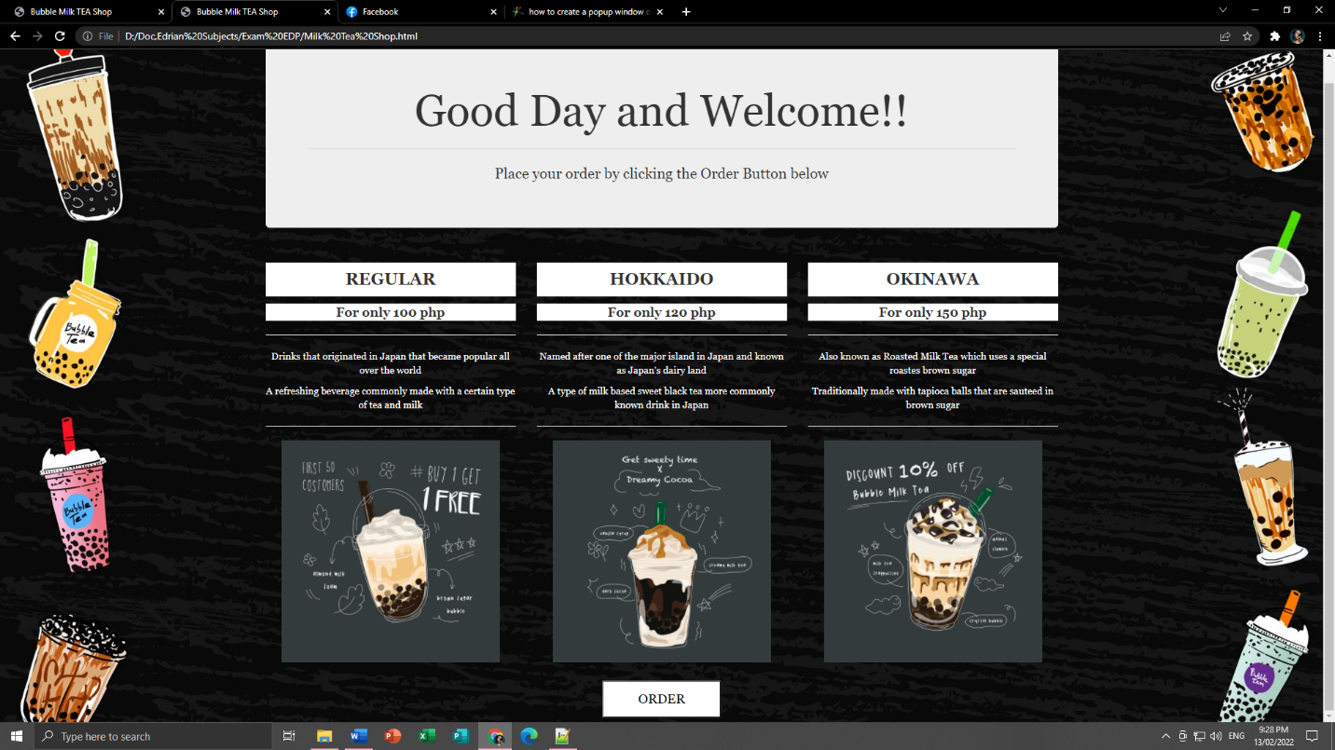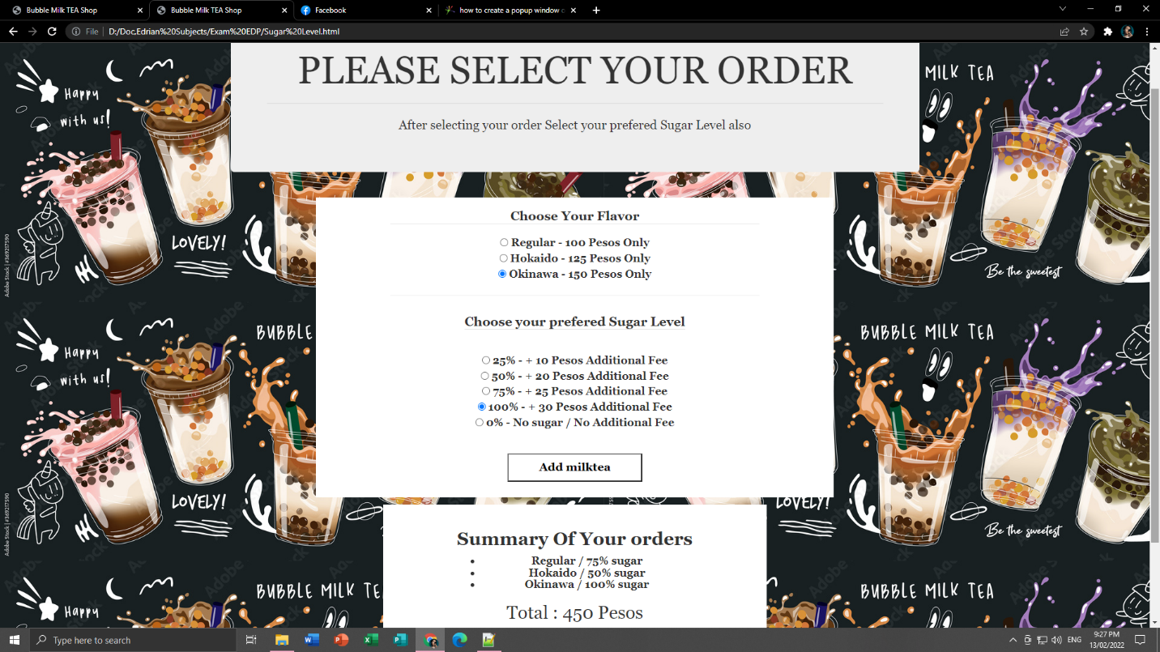**Name:** EDRIAN P. SARDEÑA

**Course/Section**: BS INFOTECH-3 A

**OUTPUT:**

**INPUT CODE:**

***HTML(First Page)***

<html>

<Title>Bubble Milk TEA Shop</title>

<head>

<body style=

"background-image: url('Images/BubbleTea.jpg');

text-align:center;font-family: Georgia;">

<html lang="en">

<head>

<title>Bootstrap Example</title>

<meta charset="utf-8">

<meta name="viewport" content=" width=device-width, initial-scale=1">

<link rel="stylesheet" href="https://maxcdn.bootstrapcdn.com/bootstrap/3.4.1/css/bootstrap.min.css">

</br><script style="background-color:white"></script>

<script style="background-color:white"></script>

</head>

<body>

<div class="container">

<div class="jumbotron">

<h1>Good Day and Welcome!!</h1><hr>

<p>Place your order by clicking the Order Button below</p>

</div>

<div class="row">

<div class="col-sm-4">

<h3 style= "background-color:white;padding: 11px 50px;"><b>REGULAR</h3></b>

<h4 style= "background-color:white;padding: 3px 1px;"><b>For only 100 php</h4></b><hr>

<p style="color:white;">Drinks that originated in Japan that became popular all over the world</p>

<p style="color:white;">A refreshing beverage commonly made with a certain type of tea and milk</p><hr>

<img src="Images/Regular.jpg" alt=" " width="314" height="320" >

</div>

<div class="col-sm-4">

<h3 style= "background-color:white;padding: 11px 50px;"><b>HOKKAIDO</h3></b>

<h4 style= "background-color:white;padding: 3px 1px;"><b>For only 120 php</h4></b><hr>

<p style="color:white;">Named after one of the major island in Japan and known as Japan's dairy land</p>

<p style="color:white;">A type of milk based sweet black tea more commonly known drink in Japan</p><hr>

<img src="Images/Hokaido.jpg" alt=" " width="314" height="320" >

</div>

<div class="col-sm-4">

<h3 style= "background-color:white;padding: 11px 50px;"><b>OKINAWA</h3></b>

<h4 style= "background-color:white;padding: 3px 1px;"><b>For only 150 php</h4></b><hr>

<p style="color:white;">Also known as Roasted Milk Tea which uses a special roastes brown sugar</p>

<p style="color:white;">Traditionally made with tapioca balls that are sauteed in brown sugar</p><hr>

<img src="Images/Okinawa.jpg" alt=" " width="314" height="320" >

</div>

</div>

</div>

</br>

<a href="Sugar Level.html">

<button style= "

background-color:white;

color: black;

padding: 11px 50px;

text-align: center;

text-decoration: none;

display: inline-block;

font-size: 19px;

margin: 6px 2px;

cursor: pointer;

font-family: Georgia;">ORDER</button>

</a>

</body>

</html>

***HTML(Second Page)***

<html>

<Title>Bubble Milk TEA Shop</title>

<head>

<body style=

"background-image: url('Images/SugarLevel.jpg');

background-attachment: fixed;

text-align:center;font-family: Georgia;">

<html lang="en">

<head>

<title>Bootstrap Example</title>

<meta charset="utf-8">

<meta name="viewport" content=" width=device-width, initial-scale=1">

<link rel="stylesheet" href="https://maxcdn.bootstrapcdn.com/bootstrap/3.4.1/css/bootstrap.min.css">

</br><script style="background-color:white"></script>

<script style="background-color:white"></script>

</head>

<body>

<div class="container">

<div class="jumbotron">

<h1>PLEASE SELECT YOUR ORDER</h1><hr>

<p>After selecting your order Select your prefered Sugar Level also</p>

</div>

</body>

<body>

<main>

</div>

<div class="milktea">

<form class="form js-milkteaForm">

<h4><div style= "background-color:white; margin: 12px auto 10px auto; display: table; padding: 20px 123px; class="milktea__block">

<fieldset class="form__fieldset">

<b><legend class="form__legend" >Choose Your Flavor</legend>

<div class="form__input-container">

<input class="form__radio" type="radio" name="milktea" value="100" id="Regular" checked>

<label class="form__label" for="Regular">

Regular

<span aria-hidden="true">-</span>

100

<span aria-hidden="true"> Pesos</span>

<span class="visually-hidden">Only</span>

</label>

</div>

<div class="form__input-container">

<input class="form__radio" type="radio" name="milktea" value="125" id="Hokaido">

<label class="form__label" for="Hokaido">

Hokaido

<span aria-hidden="true">-</span>

125

<span aria-hidden="true"> Pesos</span>

<span class="visually-hidden">Only</span>

</label>

</div>

<div class="form__input-container">

<input class="form__radio" type="radio" name="milktea" value="150" id="Okinawa">

<label class="form__label" for="Okinawa">

Okinawa

<span aria-hidden="true">-</span>

150

<span aria-hidden="true"> Pesos</span>

<span class="visually-hidden">Only</span>

</label><hr>

</div>

</fieldset>

<fieldset style= "background-color:white; margin: 12px auto 10px auto; display: table; padding: 20px 123px;class="form__fieldset">

<legend class="form__legend">Choose your prefered Sugar Level</legend>

<div class="form__input-container">

<input class="form__radio" type="radio" name="sugar" value="10" id="25">

<label class="form__label" for="25">

25%

<span aria-hidden="true">-</span>

<span class="visually-hidden">+</span>

10

<span aria-hidden="true"> Pesos</span>

<span class="visually-hidden">Additional Fee</span>

</label>

</div>

<div class="form__input-container">

<input class="form__radio" type="radio" name="sugar" value="20" id="50">

<label class="form__label" for="50">

50%

<span aria-hidden="true">-</span>

<span class="visually-hidden">+</span>

20

<span aria-hidden="true"> Pesos</span>

<span class="visually-hidden">Additional Fee</span>

</label>

</div>

<div class="form__input-container">

<input class="form__radio" type="radio" name="sugar" value="25" id="75">

<label class="form__label" for="75">

75%

<span aria-hidden="true">-</span>

<span class="visually-hidden">+</span>

25

<span aria-hidden="true"> Pesos</span>

<span class="visually-hidden">Additional Fee</span>

</label>

</div>

<div class="form__input-container">

<input class="form__radio" type="radio" name="sugar" value="30" id="100">

<label class="form__label" for="100">

100%

<span aria-hidden="true">-</span>

<span class="visually-hidden">+</span>

30

<span aria-hidden="true"> Pesos</span>

<span class="visually-hidden">Additional Fee</span>

</label>

</div>

<div form__input-container">

<input class="form__radio" type="radio" name="sugar" value="0" id="0" checked>

<label class="form__label" for="0">

0%

<span aria-hidden="true">-</span>

<span class="visually-hidden">No sugar /</span>

<span aria-hidden="true"> No</span>

<span class="visually-hidden">Additional Fee</span>

</label>

</div>

</fieldset>

<button class="form__button js-addMilktea" type="button" style= "

background-color:white;

color: black;

padding: 11px 50px;

text-align: center;

text-decoration: none;

display: inline-block;

font-size: 19px;

margin: 6px 2px;

cursor: pointer;

font-family: Georgia;">Add milktea</button>

</div>

<div style= "background-color:white; margin: 12px auto 10px auto; display: table; padding: 20px 123px;class="milktea__block">

<div class="milktea__orders-container">

<h2 class="milktea__heading">

<b><span class="aria-hidden">Summary Of</span>

<span class="visually-hidden">Your orders</span>

</h2>

<ul class="milktea__orders js-milktea-orders"></ul>

</div>

<div>

<h2 class="milktea__heading">Total

<span aria-hidden="true">:</span>

<span class="milktea__total-price js-total-price">0</span>

Pesos

</h2>

</div>

<div>

<button type="submit" onClick="refreshPage()"; class="form__button" type="button"; style= "

background-color:white;

color: black;

padding: 11px 50px;

text-align: center;

text-decoration: none;

display: inline-block;

font-size: 19px;

margin: 6px 2px;

cursor: pointer;

font-family: Georgia;">Order now</button>

</div>

</div>

</form>

</div>

</main>

<script src="./script.js"></script>

<a href="Milk Tea Shop.html">

<button style= "

background-color:white;

color: black;

padding: 11px 50px;

text-align: center;

text-decoration: none;

display: inline-block;

font-size: 19px;

margin: 6px 2px;

cursor: pointer;

font-family: Georgia;">RETURN TO MENU</button>

</a>

</body>

</html>

***Javascript***

const addMilktea = document.querySelector(".js-addMilktea");

const milkteaForm = document.querySelector(".js-milkteaForm");

const milkteaOrders = document.querySelector(".js-milktea-orders");

const totalPrice = document.querySelector(".js-total-price");

const createMilkteaOrder = ( milktea, sugarPercent ) =>{

const li = document.createElement("li");

li.classList.add("milktea__order");

li.innerHTML = `

${milktea}

<span aria-hidden="true">/<span>

${parseInt(sugarPercent)? `${sugarPercent}%` : "No "}

sugar

`;

return li;

}

const getSingleRadio = group =>{

const groupList = Array.from(group);

const selectedRadio = groupList.filter(radio => radio.checked);

return selectedRadio[0];

}

const handleAddMilktea = event =>{

const { milktea, sugar } = milkteaForm;

const selectedMilktea = getSingleRadio(milktea);

const selectedSugar = getSingleRadio(sugar);

const newOrder = createMilkteaOrder(selectedMilktea.id, selectedSugar.id);

milkteaOrders.appendChild(newOrder);

const currentTotalPrice = parseInt(totalPrice.textContent);

const newTotalPrice = currentTotalPrice + parseInt(selectedMilktea.value) + parseInt(selectedSugar.value);

totalPrice.textContent = newTotalPrice;

}

addMilktea.addEventListener("click", handleAddMilktea);